Unit Testing Steps For Given Dev Challenge

1 Build the project 2
1.1 maven build 2
2 Test the functionality 2
2.1 Do the post request to restful service 2
2.2 Update the shop information/details 3
2.3 To get all the shops details submitted by post request 3
2.4 To get nearest shop by providing Longitude and latitude of the user 4

- Build the project
  - Gradle build
Here I have created the gradle project and have defined all the required dependencies inside build.gradle

To start the build and to download the required jars, run the following command from the root directory of project:

gradle build

This would build the entire project and would download the respective jars inside repository.
It would create the executable jar file of the project under build/libs folder. As we are using spring boot, it comes with embedded tomcat.
After running the jar file it would deploy and start the application.

- Test the functionality
  - Do the post request to restful service
Here I am using Mozilla’s rest client plug-in to test the code.
To add a new shop inside memory, make the following call by selecting POST HTTP method inside client:
http://localhost:8080/shops/
Select the header inside REST Client and add a header type for json
Content-Type: application/json
In body give the details of shop in json format
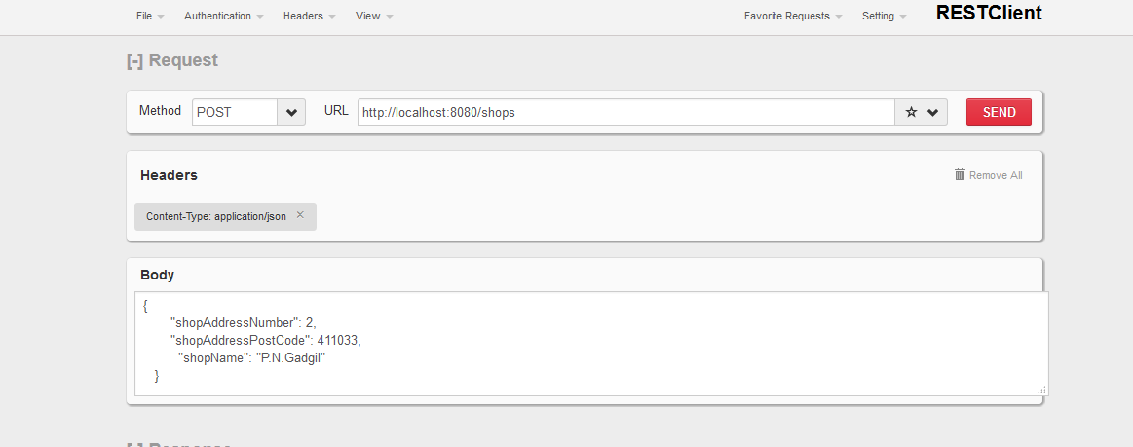

This will add the new shop inside memory with provided details by calling method –addShop of ShopReource.java which consumes and produces Json data.
Same way we could add the shops details of different shops.
  - Update the shop information/details
Internally it will call the Google Map API service (code written in AddressConverter.java) to get the longitude and latitude for the added shop. Once it receives response from google API, it updates the existing shop object with received values of longitude and latitude.
  - To get all the shops details submitted by post request
Below url can be accessed with HTTP GET method inside REST client of Mozilla to get all the shops details in json format:
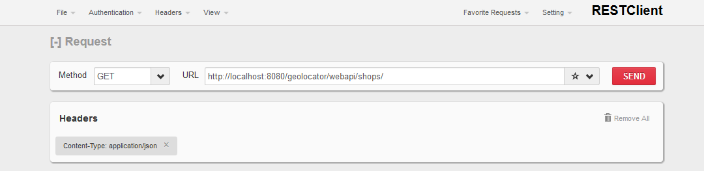
It would call the getShops method and which gives the response in json format as shown below:
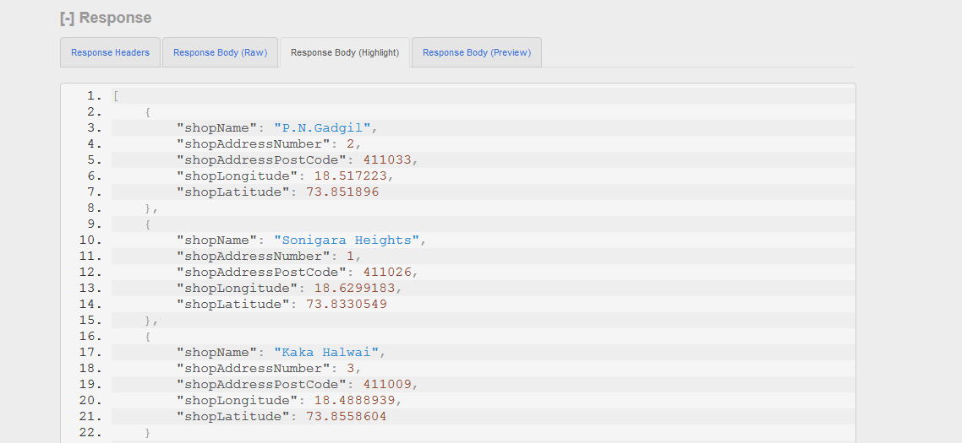

  - To get nearest shop by providing Longitude and latitude of the user
Now as we have the shops details with its longitude and latitude inside memory.
We can make a GET request by providing the longitude and latitude of our location, to get the nearest shop from the above shop list.
URL: : http://localhost:8080/geolocator/shops/query?lng=73.7857032&lat=18.6209663
Here I am passing the lng and lat of the user as a query parameters.
This would invoke a method getShopsByLngLat() with given Query parameters and the path would be /query
It would call the CommonUtility.java method distance (double lat1, double lon1, double lat2, double lon2, String shopName) to get the nearest distance.
By calculating and executing the business logic it would return the shop details which is nearest from the user location.
Result:
